**How to start and succeed in the maize production business**

Compared to many other crops, maize is quite easy to produce. However, succeeding in the maize production business requires knowledge and skill.

Based on my research, we have identified some things entrepreneurs should consider and keep in mind if they plan to get involved in the maize business. Here they are:

**Find suitable land**

The first and most important thing you will need to get started with maize production is land.

Maize grows best in rich loamy or sandy-loam soils in a well-drained area that has a flat or fairly flat landscape. Maize will not do well in waterlogged land. If the land is not well drained, you could make ridges or mounds to protect the crops from waterlogging.

Because the maize plant loves sunlight, the land has to be in the open and free from any kind of shade (such as tall trees or man-made structures) that prevents sunlight from reaching the planted maize.

The land has to be cleared and tilled before the rainy season starts and the maize should be planted immediately after the land is prepared. If this is not done, weeds may grow fast and compete with the maize for nutrients and sunlight.

**Use the right varieties**

There are different varieties of maize in the world today and the type you choose to produce will depend on consumer preferences and market demand in your area.

In some localities, white corn is more popular than the yellow variety. In some other areas, it is vice-versa. However, the best maize varieties grow fast, are high yielding, mature earlier than the local varieties and are resistant to major pests and diseases.

There are now some hybrid varieties that use much less water and can often survive in drought-prone areas.

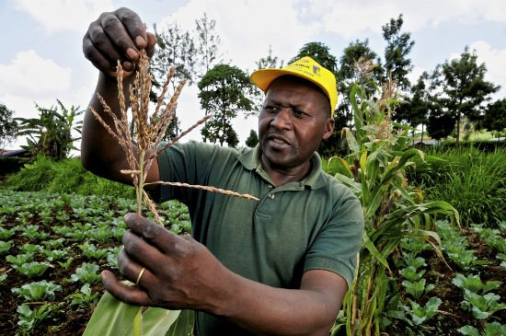  
Maize farmer in Kenya / Photo credit: CIAT International Center for Tropical Agriculture; Flickr

There are also late-maturing and early-maturing varieties of maize.

Late-maturing varieties mature in 110-120 days and are good for zones with a long rainy season.

Early-maturing varieties mature in 90-100 days and can be planted after a late-maturing variety in zones with two seasons of rainfall.

There are also extra-early varieties which mature in 80-90 days. These can be planted in zones with very short rainy season (usually 2-3 months long).

**When and how to plant maize**

Time was when rainfall patterns in my village were predictable. I guess climate change is ‘changing’ everything nowadays.

There are now no specific dates to plant maize. Depending on your region, you could follow the previous history of rains in the area. However, it’s best to plant after it has rained consecutively for 2 to 3 times.

Planting only when the rains have come will help the maize seeds to germinate and grow well.

Some maize varieties need between 450 to 600 mm of water per season to grow, most of which it gets from moisture reserves in the soil.

According to [research](http://www.arc.agric.za/arc-gci/Fact%20Sheets%20Library/Maize-infopak.pdf), at maturity, it is estimated that each maize plant will have consumed about 250 litres of water.

It is also very important that you pay very close attention to the health of the maize seeds you plant. You should only buy maize seeds for planting from dependable sources.

For best results, avoid buying maize seeds from the local or open market near you. These seeds could be rotten or already contaminated by disease which will likely affect its growth performance.

I have included a manual in the resources section (at the end of this article) that contains specific information on how to treat maize seeds before planting.

**Watch out for weeds, pests and diseases!**

There are several types of weeds, pests and diseases that affect maize plants such as stem borers, army worms, grasshoppers, larger grain borers, downy mildew, maize streak virus and Striga among others.

Fortunately, there are several herbicides, pesticides and disease control methods you can apply to prevent a breakout on your farm. The manual in the next section contains useful information about these methods and how you can apply them.

**Harvest: what can you expect?**

The amount of maize that can be harvested (per hectare) depends on the variety you planted, amount of rainfall, sunshine and the level of weed, pest and disease control management that was applied.

Although Africa has some of the lowest maize yields in the world, it is not uncommon to expect between 2,000 to 4,000 kilograms per hectare.